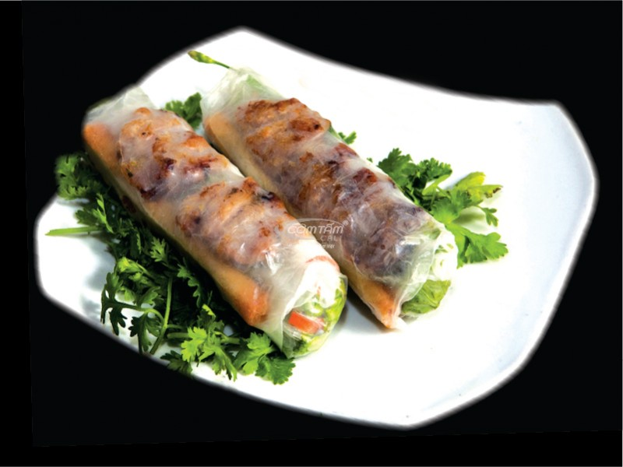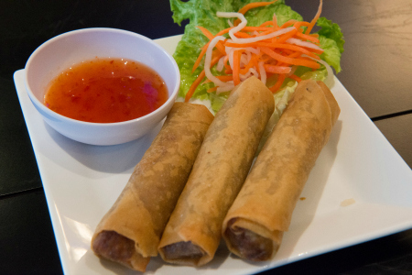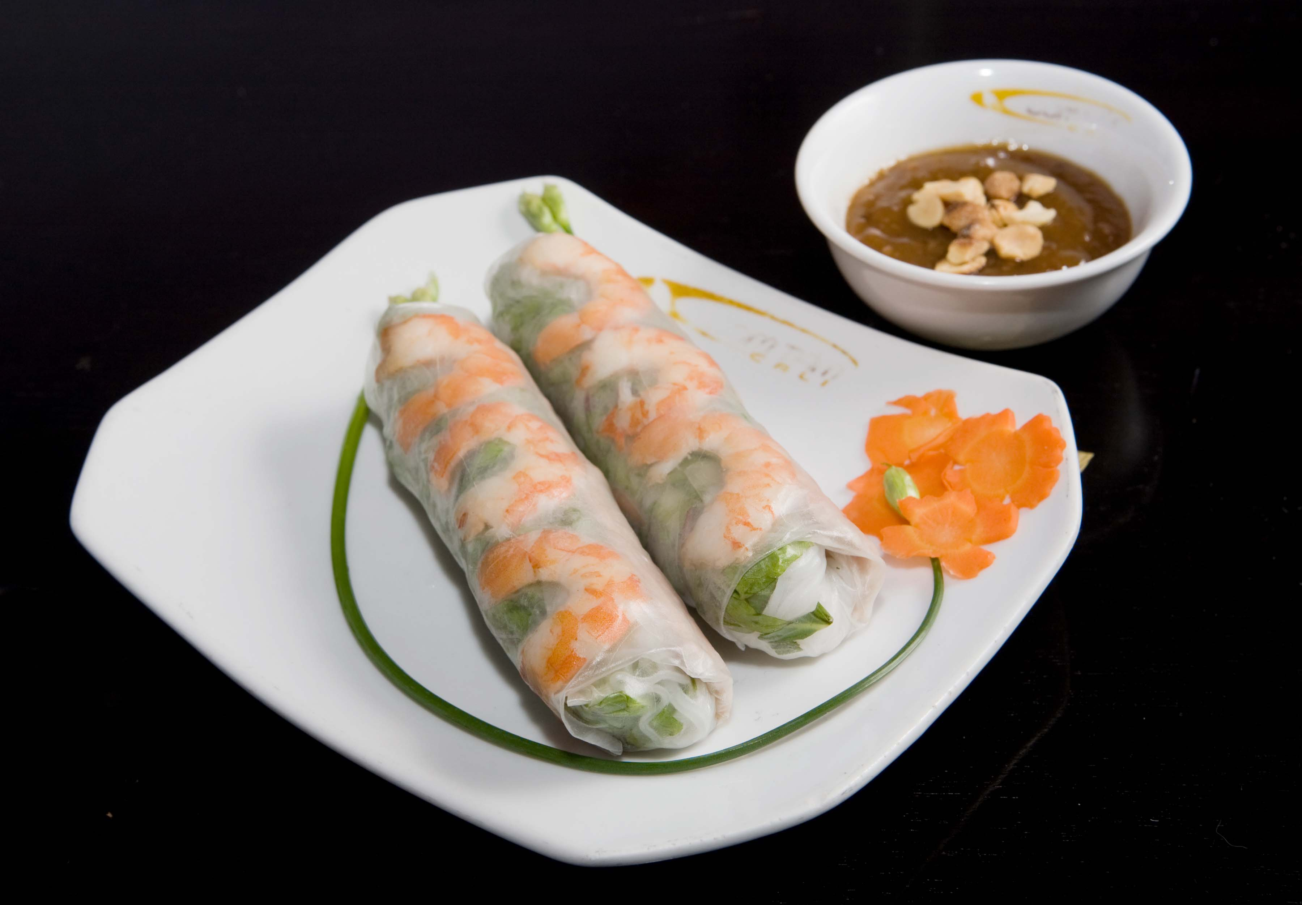

**A1. Salad Rolls** (2 rolls per order)- Shrimp, slice pork, rice noodles, bean sprouts lettuce, wrap in thin rice paper, and creamy peanut dipping sauce.

wawwra

**7.25**

**A2. Egg Rolls** (3 rolls per order)- savory **roll** with shredded cabbage, carrot, ground pork, and ground chicken fillings inside a thickly wrapped wheat flour skin, which is fried in hot oil.

V

**V2. Vietnamese beef salad-** cook beefsteak, lettuce, and shredded carrot, white onions, cilantro, peanuts, and vinaigrette dressing

**V3**. **Vietnamese shrimp salad-** cook shrimp, lettuce, shredded carrot **8.95**

White onions, cilantro, peanuts and vinaigrette dressing

**V4**. **Vietnamese chicken salad**- cook chicken breast, lettuce, shredded carrot **8.25**

White onions, cilantro, peanuts, and vinaigrette dressing

**Pork skin spring rolls (2 rolls)-** pork, pork skin, rice noodles, bean sprouts **6.45**

Lettuce, wrap in thin rice paper, and dipping fish sauce or peanut sauce.

**Grill pork spring rolls (2 rolls)-** grill pork, rice noodles, bean sprouts **7.25**

Lettuce, wrap in thin rice paper, and dipping fish sauce or peanut sauce

**Deep Fried Tofu (6 pieces)-** served with soy sauce. **6.25**

**V6. Vegetarian egg rolls (3 rolls)-** savory roll with shredded cabbage, taro **7.25**

And carrot fillings inside a thickly wrapped wheat flour skin, which is fried in hot oil.

**V7.** **Vegetarian Salad rolls (2 rolls)-** fried tofu, lettuce, bean sprouts, rice noodles **6.45**

wrap in thin rice paper, and creamy peanut dipping sauce.

Consuming raw or undercooked meats, poultry, seafood, shellfish, or eggs may increase your risk of foodborne illness, especially if you have certain medical conditions. Please inform your server of any food allergies or dietary restrictions.

**8.25**

Grill pork

A2

**A1**

# Appetizers

* **All Appetizers Made To Order. Please No Return or Exchange**

Pho Vinh

**6.45**